Silverlight/Javascript/Blend Website How-To

Written by Jeff Paries
http://www.designwithsilverlight.com

Not to be reproduced or redistributed without permission.
©2007

Introduction:
This tutorial describes how to go about creating a Silverlight based website like www.designwithsilverlight.com (shown in figure 1). Several programs were used to create the site, including Photoshop, Expression Design, Blend, and an HTML editor for the scripting side of things.

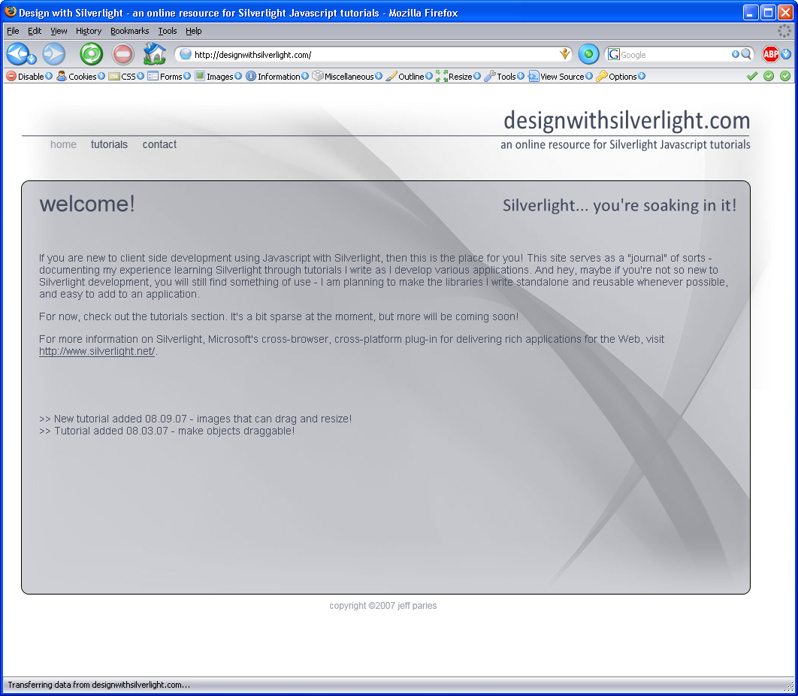
Figure 1

Design:
The design for the website was initially laid out in Photoshop. This was done more for the flexibility of testing out different ideas and developing the look and feel prior to putting effort into creating the site itself. Once the look and feel was done, I utilized Blend to actually develop the site.

Development:
After beginning a new project in Blend, the initial page canvas was renamed to “rootCanvas” – this is something I have gotten into the habit of doing, and saves me trouble if I need to reference it in my script because it will always be called the same thing.

To the rootCanvas, I added an image object, called “backgroundImage”, which contains the grayscale Silverlight logo background.

The next thing I added (in no particular order) was the “designwithsilverlight.com” text in the upper right hand corner. Here is where I ran into a bit of a headache. Blend does not support GIF images, and I needed transparency to “cut out” the text from its background. I tried a PNG file, but it looked really bad, and I wanted nice, clean, crisp text. I also wanted to make sure the presentation would be consistent cross browser/platform. The best solution I could come up with was to use Expression Design to create the text as paths. The downside is that text as paths bloats the size of the site. The upside is that text as paths gives me what I wanted.

To make certain the text was sized accurately, I saved out the individual text layers from Photoshop as separate images, and then imported them into Design using File/Open. Figure 2 shows some example text done in Copperplate type saved as a GIF file, and opened in Design.

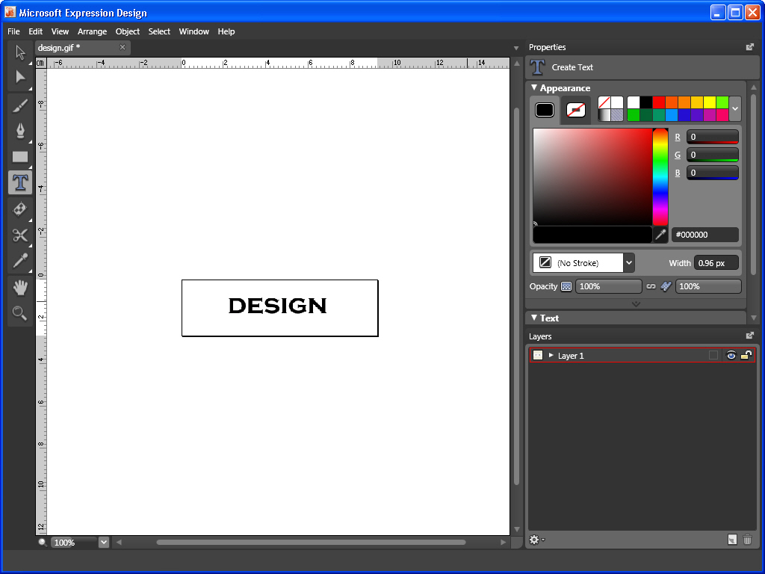
Figure 2

I then selected the Text tool, and clicked near my image, typing in the same text that was in the image. Once the text was in, I selected it all, and then changed the font face, size, etc. to match the dimensions of the text in the image. This was relatively easy to do in Design – once the text is typed in, click the Selection tool, and you can scale/translate the text into position fairly quickly. Figure 3 shows the new text typed in over the GIF image.

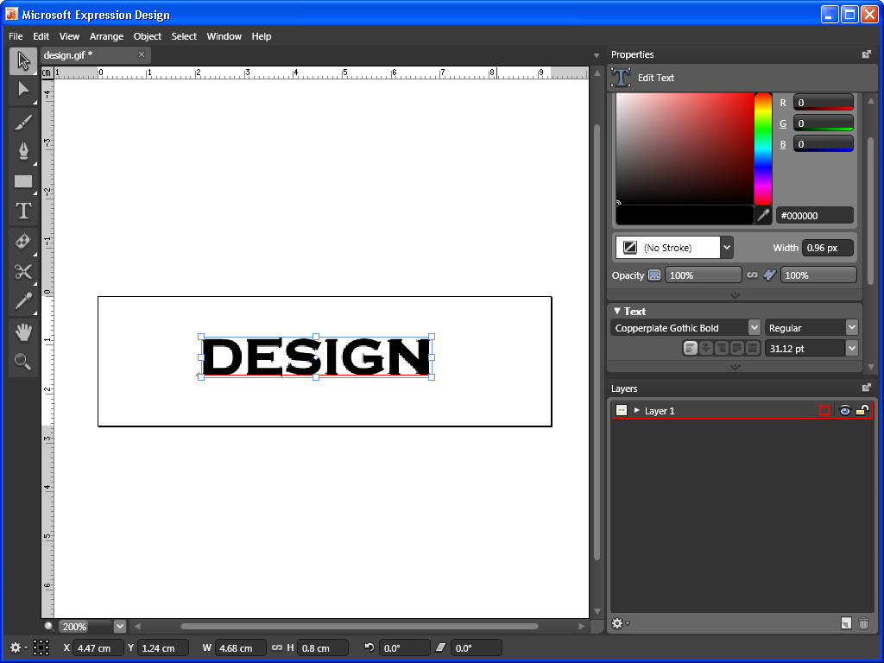Figure 3

Once that is done, all you need to do is export the paths as XAML and paste the XAML code into Blend. With the text selected, pick Object/Convert Object to Path. Pick File/Export, and change the “Save as type” to XAML. Design will open an Export XAML dialog.

There are two tabs to the right of the view area - Graphics and XAML. Click the XAML tab. I used the mouse to select the Canvas object that contained my text paths (figure 4), and then did a Ctrl+C to copy. I switched over to Blend, picked the XAML tab, and pasted the new code into my project file.

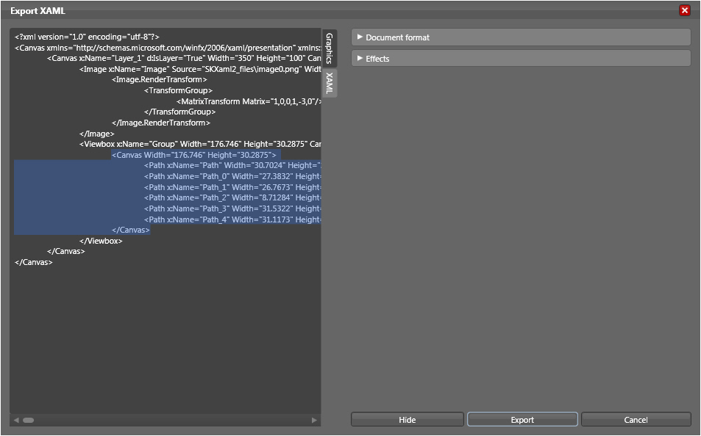Figure 4

The text object was now in my project, and looked great! Figure 5 shows what the design workspace looked like after pasting in the new code.

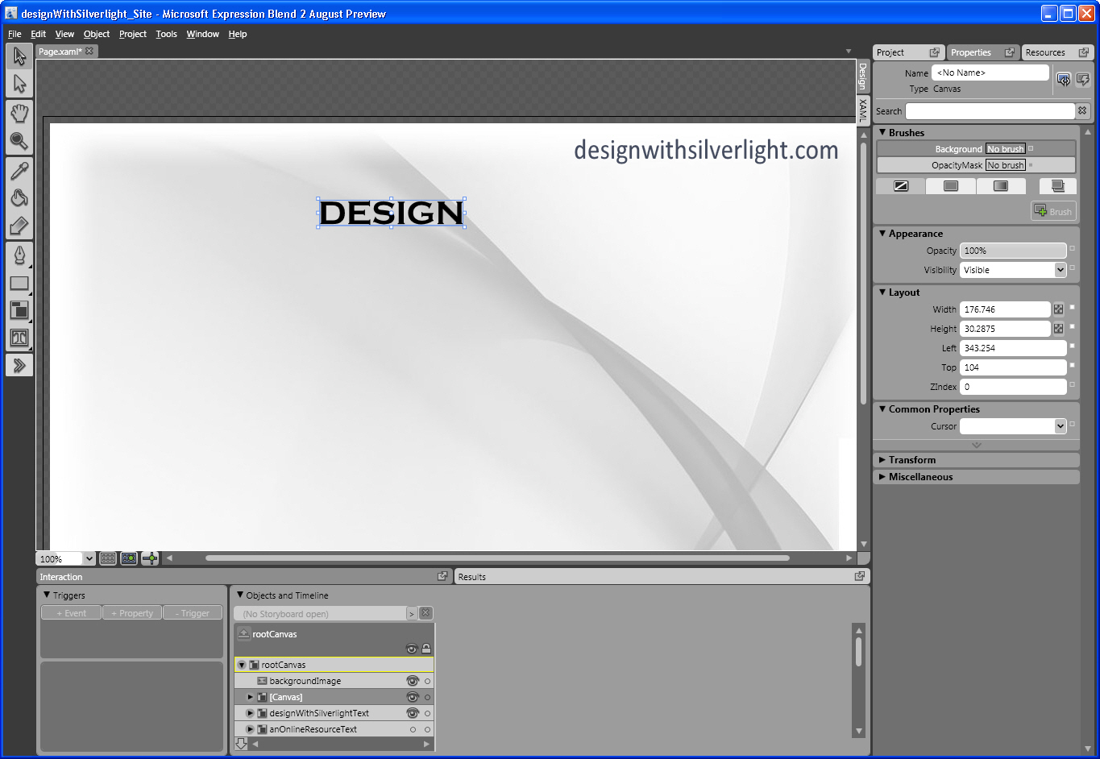
Figure 5

If your preference is to use Illustrator for vector based artwork and/or fonts, there is a nice XAML exporter you can read about/download at http://www.mikeswanson.com/xamlexport/.

Notice the naming convention for the paths in figure 4. The paths follow a generic naming convention – Path_0, Path_1, etc. This was going to be a problem because I had a lot of text objects to add, and the XAML becomes invalid if two objects share the same name.

As I continued to add text objects, I developed a naming convention that worked for me – you may find something else that works better for you. I named the paths something descriptive based on the text object, followed by the letter the path represented. For example, the “contact” menu item has seven paths, named “contactC”, “contactO”, “contactN”, “contactT”, “contactA”, “contactC2”, and “contactT2”. Note that the second “C” and second “T” have “2” appended to them. Longer phrases continue that convention to make each path name unique. I didn’t start doing this until I was partway done building the site and realized I needed some way of organizing the paths, so the code is not all as clean as it should be.

Using that same technique, I created paths for all of the main text objects on the page – designwithsilverlight.com, an online resource for Silverlight Javascript tutorials, welcome! Subhead, tutorials subhead, contact subhead, and Silverlight… you’re soaking in it! After some experimenting, I felt like the textBlock object was more than adequate for the menu items themselves, so they were done as textBlocks rather than paths. Similarly, the copyright text at the bottom didn’t need to be anything fancy, so it is just a textBlock as well.

I found out once I started animating the menu items that I needed a second copy of the menu text as well, so each menu item was copied, and then renamed in a descriptive fashion. For example, the text for the home button is called “btnTextHome”, and the copy was named “btnTextHomeAnim” so I knew which one to work with when creating storyboards. I grouped each pair of menu text items onto its own canvas to make it easier to manipulate them. This was done by selecting both objects, then right clicking and picking Group Into/Canvas. This was done strictly for organizational purposes and to make moving objects around easier. You may find a method that works better for your projects.

The last two items I needed to add were the horizontal rule above the menu items, and the darker gray content area. The horizontal rule is a simple path, and the content area is a canvas containing two rectangles with rounded corners. One rectangle serves as the stroke, with no transparency while the other serves as the main panel, which is 26% opaque and colored bluish-gray.

At this point, my Blend project workspace looked like figure 6:

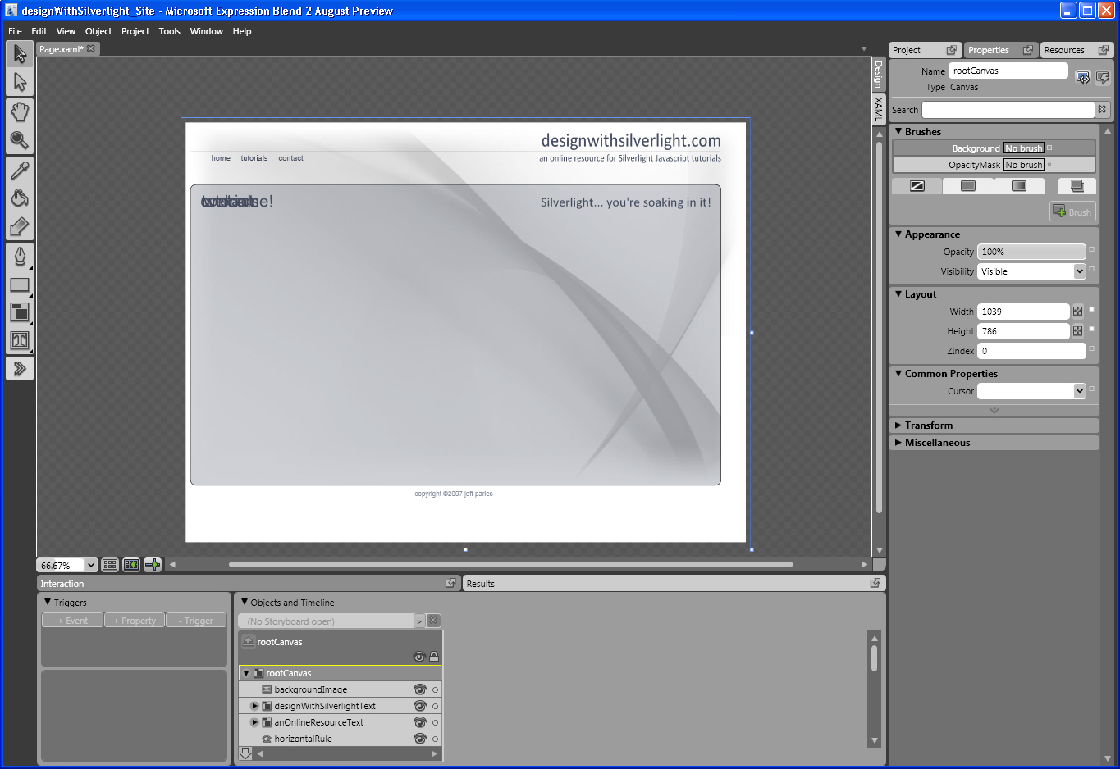
Figure 6

Notice that the subhead text objects are all piled on top of one another in the same spot. This is the location where they will be appearing on the site.

The next step was to create timelines (animations) for the various objects on the page. I had sketched out some idea of what I wanted to have happen and how. There are 7 total timelines for this site. One that plays when the page is loaded, one each for when the menu items are clicked, and one for each subhead that plays when a menu item is clicked.

To create the timelines, I selected the “Open, create, or manage storyboards” button just above the objects list (to the right of the “(No Storyboard open)” text), then clicked the “+” icon to add a new storyboard.

Each animation was named something descriptive, such as menuHomeClick, and created as a resource so that they could be manipulated via Javascript.

The animations are fairly simple. Once the new Timeline has been created, Blend will enter a Timeline Recording mode, where changes made to the properties of an object are recorded as keyframes. The animation works by “tweening”, meaning you set the keys, and the software generates the in between frames. With the “anim” component of my menu item selected (btnTextHomeAnim), I clicked the Record Keyframe button to save the initial state of the object. I then advanced the timeline to 0:00.500 by using the “Go to next frame” button.

Once there, I changed the Opacity to 0 and both the X and Y scale to 5 (500%). This creates the effect of the text scaling up while it is fading out. Once I had it the way I liked it, I turned off the timeline recording by clicking the red button in the top left hand corner of the workspace, and set the visibility of the “anim” object to “Collapsed” to hide it. The visibility will be turned on via script when needed.

At this point, you can either create identical animations for the other two buttons, or copy and paste the XAML code for the storyboard that was just created, and then edit the name and TargetName for the animation.

The subhead animations are equally as simple. Using the same process of creating a new timeline for each of the three subheads, I changed the opacity property over 1 second from 0 to 100%, creating a fade in effect.

The final animation was the onload animation that fires when the page has finished loading. It is slightly more involved. On frame zero, the opacity for the following objects was set to 0% to essentially display a blank page when the site is first loaded: the content canvas (blue gray background), designwithsilverlight.com, an online resource for Silverlight Javascript development, home menu item, tutorials menu item, contact menu item, welcome! Subhead, tutorials subhead, contact subhead, and Silverlight… you’re soaking in it text.

I wanted different things to happen at different speeds, and a big part of it was just tweaking the settings to see how things “felt” as I went along. The way it ended up was with the designwithsilverlight.com text opacity at 0 up until frame 0:00.500. At frame 0:02.000, opacity is 100%. Because I wanted things to fade in one at a time, the opacity for “an online resource...” was set to 0 at this frame, and 100% at frame 0:04.000.

Next up were the three menu items, which would start out large, then scale down to their positions on the page. At frame 0:04.000, opacity was set to 0%, and both X and Y scales were set to 3 (300%). 3 frames later, at 0:04.300, opacity is 50% and XY scale 1. Starting on 0:04.300, the tutorials button does the same thing with the exception that on frame 0:04.600, the opacity is 100%. Starting on frame 0:04.600, the contact button does the same thing as the tutorials button, through frame 0:04.900. The opacity on the home button stopping at 50% is to leave the button faded out, since home is the default selected menu item.

At frame 0:04.900, the background canvas opacity was set to 0%, and advances to 100% on frame 0:06.900. Both the “welcome!” and “Silverlight… you’re soaking in it” text start with opacity 0% on frame 0:06.900, advancing to 100% on frame 0:07.900. Figure 7 shows the completed timeline.

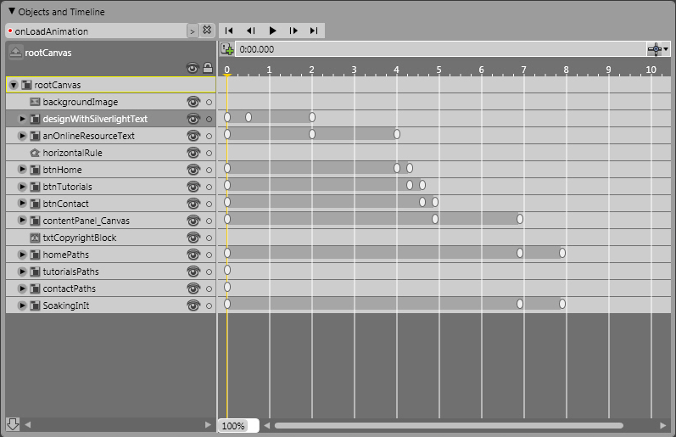
Figure 7

Now that all of the graphics were in place for the layout, and the storyboards had been created, it was time to wire up some events to make things happen. The main content of the site is all on one page, stored in separate named divs. The opening flow of the site is to play the onload animation when someone first comes into the site, and then display the home content div.

To fire the onload animation, an event was added to the rootCanvas to call a function called “pageLoaded”:

<Canvas
xmlns="http://schemas.microsoft.com/client/2007"
xmlns:x="http://schemas.microsoft.com/winfx/2006/xaml"
Width="1039" Height="786"
x:Name="rootCanvas" Loaded="pageLoaded">

This function very simply plays the onload animation, and looks like this:

function pageLoaded(sender) {
sender.findName("onLoadAnimation").begin();
}

The onload animation had an event trigger added to it, called “Completed”. This event will fire when the onload animation is done playing. The code for the event looks like this:

<Storyboard x:Name="onLoadAnimation" Completed="onLoadAnimationDone">

The function being called, onLoadAnimationDone simply makes the initial content div for the site visible, as follows:

function onLoadAnimationDone(){
document.getElementById('homeContent').style.visibility = 'visible';
}

Next, script needs to be added so that when a menu item is clicked, the non clicked content divs are hidden while the correct (requested) one is shown. To do this, an event is added to the textblock object – this example shows the “tutorials” text:

<TextBlock MouseLeftButtonDown="menuTutorialsSelected" x:Name="btnTextTutorials" Width="49.5" Height="22.5" Canvas.Left="0" Canvas.Top="4.25" FontFamily="Arial" FontSize="14" Foreground="#FF444C5F" Text="tutorials" TextWrapping="Wrap"/>

The function being called is shown below:

function menuTutorialsSelected(sender, mouseEventArgs) {
document.getElementById('homeContent').style.visibility = 'hidden';
document.getElementById('tutorialContent').style.visibility = 'hidden';
document.getElementById('contactContent').style.visibility = 'hidden';

sender.findName("welcomeSubheadAnim").stop();
sender.findName("contactSubheadAnim").stop();
sender.findName("homePaths").opacity = 0;
sender.findName("contactPaths").opacity = 0;

if (!tutorialsClicked) {
sender.findname("btnTextTutorialsAnim").Visibility = "Visible";
sender.findName("menuTutorialsClick").begin();
sender.opacity = 0.50;
sender.cursor = "Arrow";
sender.findName("btnHome").opacity = 1;
sender.findName("btnTextHome").opacity = 1;
sender.findName("btnTextHome").cursor = "Hand";
homeClicked = false;
tutorialsClicked = true;
sender.findName("btnTextContact").opacity = 1;
sender.findName("btnTextContact").cursor = "Hand";
contactClicked = false;
sender.findName("tutorialsSubheadAnim").begin();
}
}

The first thing it does is hide the content for all three sections of the site (just to make sure things are cleaned up). It then stops the other two subhead animations that could be playing, the welcome! subhead animation, or the contact subhead animation. Additionally, the welcome and contact subhead text is hidden by setting the opacity of both to 0.

It then tests to see if the tutorials button has been clicked. The default Boolean value for the tutorialsClicked variable is false, because when you first come to the site, the “home” button is the selected item.

By checking to see if tutorials was already selected (if (!tutorialsClicked)) the if statement will run the rest of the commands shown. The if statement proceeds to make the animated version of the menu text visible, and then play the animation. It dims the selected menu item to 50%, and changes the cursor to an arrow rather than a hand. It then resets the other menu items opacity to 100% so they are not dimmed, changes the cursor for them back to a hand, and resets the flags tracking which menu item is selected.

Now that the menu items have been set and the header animation plays, I needed to add an event to the subhead animation to show the appropriate content when the animation finishes.

<Storyboard x:Name="tutorialsSubheadAnim" Completed="tutorialAnimationDone">

The tutorialAnimationDone function very simply flips the visibility of the three divs such that the home and contact divs are hidden, and the tutorial div is displayed.

function tutorialAnimationDone() {
document.getElementById('homeContent').style.visibility = 'hidden';
document.getElementById('tutorialContent').style.visibility = 'visible';
document.getElementById('contactContent').style.visibility = 'hidden';
}

Both the home and contact buttons work in the same fashion, calling a function to do some cleanup work before playing an animation of the menu item that when completed calls a function to display some content.

That pretty much sums up how the majority of the site was built out and runs.

